
BASIC STATISTICS

ASSIGNMENT REPORT

TOPIC – Utilize state-wise data on length of National Highways,
State-wise Length of Roads and State-wise Length of State Highways to understand the infrastructural development and policy formulation to address challenges across states.

Name – Mayukh Paul
Program: B. Sc Economics (Hons.)
4th Semester, 2nd Year
Department: Economics
Enrolment ID: 2211212001006
Registration No: 220010026832

INTRODUCTION
IOP Conference Series: Materials Science and Engineering, Volume 512, 10th Malaysian Road
Conference & Exhibition 2018 29–31 October 2018, Selangor, Malaysia Citation C P Ng et al 2019 IOP Conf. Ser.: Mater. Sci. Eng. 512 012045DOI 10.1088/1757-899X/512/1/012045


Infrastructure development plays a pivotal role in fostering economic growth, enhancing connectivity, and improving the quality of life for citizens. In Central India, the length of National Highways (NH), State Highways (SH), and State Roads serves as a crucial barometer of infrastructural development. (¹ Department of Civil Engineering, Faculty of Engineering, University Perthane Nasional Malaysia, Kuala Lumpur, Malaysia)

A breadth of research [1-6] revealed that the road infrastructure development was positively associated with economic growth. Generally, road infrastructure plays a crucial role by providing mobility for the efficient movements of people, goods and services as well as providing accessibility to land and a wide variety of commercial and social activities [7]. The provision of road infrastructure not only lower the physical barrier by stimulating the movements of people, goods [8] and services but also improve access to markets, social services and employment by reducing the overall transportation times and costs. The development or provision of high mobility road infrastructure such as expressway can increase the speed and improve the efficiency of domestic and international trades by reducing the transportation times and costs; whilst the development or provision of high accessibility road infrastructure such as local road allow easy land access and promote commercial and social activities at local level [9-10].

This study aims to utilize state-wise data on the length of NH, SH, and State Highways to comprehensively analyse infrastructural development in Central India. By examining trends, disparities, and challenges in road infrastructure, this research endeavours to provide insights that inform policy formulation and strategic interventions to address infrastructural gaps effectively.

As of Jan 2024, India has 146,145 km of NHs, which is 60% increased from 2014. The NH network plays a vital role in the country’s social and economic development by improving access to markets and enable the efficient movement of passengers and freight.

As of Jan 2023(State Highway), India has 186,908 km of state highways. Maharashtra has the largest state highway network in the country, followed by Karnataka, Gujrat, Rajasthan and Andhra Pradesh.

As of Jan 2024, India has 634,5403 km of other roads.

MARKET SIZE
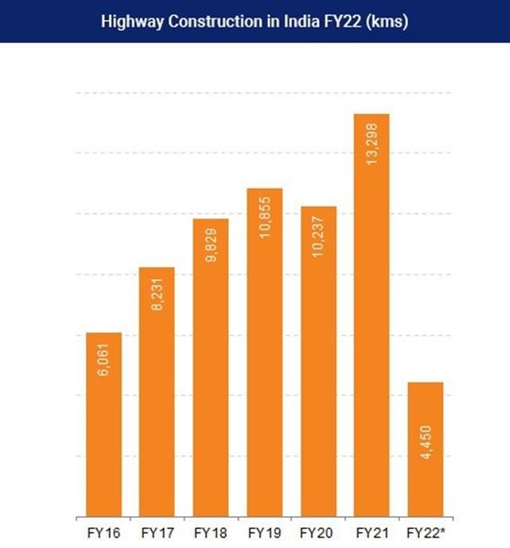
National highway construction in India increased at 5.3% CAGR between FY14-FY23. Despite pandemic and lockdown, India has constructed 10,457 km of highways in FY22. In FY23, the
Ministry of Road Transport and Highways constructed national highways extending 10,331 kms. Under the Interim Budget 2024-25, the Government of India has allocated Rs. 2.78 lakh crore (US$ 33.46 billion) to the Ministry of Road Transport and Highways.
India's road network has
grown 59% to become the second largest in the world in the last ten years. India has nearly 66.71 lakh km of total road network and the National Highways network alone stood at 146,145 km in CY 2023.
India had a total of 97,830 km of National Highways in 2014-15 which has expanded to 146,145 km by December 2023.
In FY24 (until November), cumulatively 5,248 km of National Highways have been constructed.
A total of 202 national highway projects worth Rs. 79,789 crore (US$ 9.59 billion) are at the implementation stage in the country and are 6,270 km in length.
In October 2020, the foundation stone was established for nine National Highway projects— with a total length of ~262 kms—worth >Rs. 2,752 crore (US$ 371.13 million) in Tripura.

LITERATURE REVIEW
The importance of highway infrastructure in state employment growth could be either underestimated or overestimated if the spatial dimension of highway impacts is ignored. With network externalities, highway infrastructure could have spatial implications across jurisdictions. A new or improved highway, for instance, could enhance the connectivity of other highways in the entire network; therefore, the economic effects can be distributed over space. In addition, geographic spillovers of highway impacts could arise from the fact that improving highway infrastructure may alter the comparative advantage across locations, leading to the spatial redistribution of economic activities from states with relatively poor highway facilities to those with well‐developed highway infrastructure systems.¹ While the empirical literature testing these spatial spillover hypotheses is growing, much of previous work is concerned with productivity and output spillovers from transport infrastructure (e.g. Holtz‐Eakin and Schwartz 1995; Kelejian and Robinson 1997; Boarnet 1998; Pereira and Roca‐Sagalés 2003; Pereira and Andraz 2004; Cantos et al. 2005). To date, relatively little effort has been given to gaining insights into the existence of the spillover effects of transport infrastructure provision on the job market. In this paper, we also examine the possibility of employment spillovers from highway investments in a Granger causality framework.

OBJECTIVE TO STUDY
The objective of this report is to provide and understand the infrastructural challenges of 4 Central states – Madhya Pradesh, Chhattisgarh, Jharkhand, West Bengal by state-wise length of national highways (NH), state-wise length of roads and state-wise length of state highways (SH). This study aims to comprehend the infrastructural development status and formulate policies to address challenges across different states in the region.

METHODOLOGY
- Data Collection: Gather state-wise data on the length of National Highways, State Highways, and total road length from reliable sources such as government databases, transportation departments, or research institutions. Ensure data consistency and accuracy across all states in Central India.
- Data Analysis: Calculate the average length of National Highways, State Highways, and total roads for each state in Central India. Compare the infrastructural development levels across states to identify disparities and trends. Conduct statistical analysis to identify correlations between road
- Stakeholder Engagement: Engage with stakeholders such as government officials, transportation authorities, local communities, and experts in infrastructure development. Conduct interviews, focus groups, or surveys to understand the specific challenges faced by each state regarding road infrastructure
- Identify Challenges: Identify common challenges across states in Central India, such as inadequate road connectivity, poor road quality, traffic congestion, or insufficient maintenance.
- Policy Formulation: Based on the analysis and stakeholder inputs, formulate targeted policies to address identified challenges. Prioritize policy interventions based on urgency and potential impact. alignment with national and regional development goals and strategies.
- Implementation Strategy: Develop an implementation strategy outlining the steps, timelines, responsibilities, and resources required to execute the formulated policies effectively. Consider collaboration with relevant stakeholders and the allocation of funding and resources.
- Monitoring and Evaluation: Establish mechanisms for monitoring the implementation of policies and assessing their effectiveness.

DATA AND VARIABLES
The Road infrastructure development of the year 2016-2019
• State Wise-Length of National Highways (2016-2019) [TABLE 1]

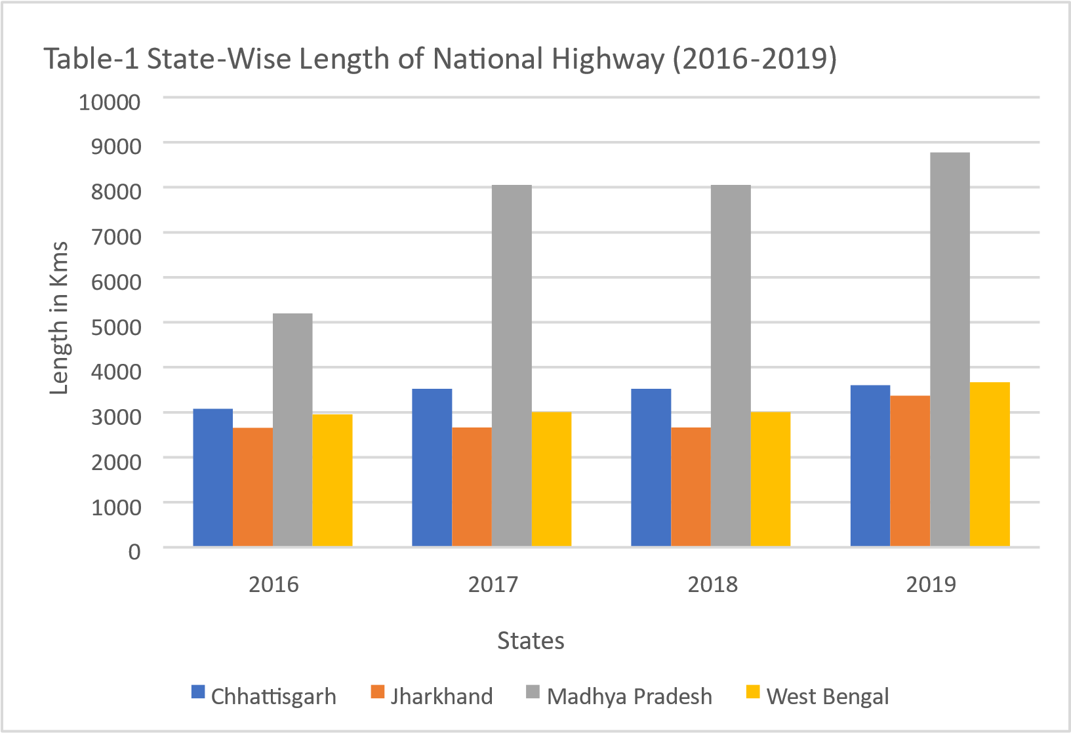

Trends
From the graph depicting the state-wise length of national highways from 2016 to 2019, several observations can be made:
- Steady Growth in Chhattisgarh and Jharkhand: Both Chhattisgarh and Jharkhand show a consistent increase in the length of national highways over the four-year period. While Chhattisgarh's highways grew from around 3,000 km to approximately 3,600 km, Jharkhand's highways expanded from about 2,600 km to around 3,400 km. This growth suggests ongoing infrastructure development efforts in these states.
- Significant Growth in Madhya Pradesh: Madhya Pradesh exhibits substantial growth in the length of its national highways, particularly between 2016 and 2019. The highways increased from approximately 5,200 km to over 8,700 km during this period, indicating significant infrastructure expansion and development initiatives in the state.
- Fluctuations in West Bengal: West Bengal shows fluctuations in the length of its national highways over the four-year period. While there is a slight increase in 2017 and 2018, there is a notable jump in 2019, with the length of highways reaching around 3,665 km. These fluctuations could be attributed to various factors such as infrastructure projects, maintenance activities, or changes in highway classifications.
- Overall Trend of Growth: Despite fluctuations in individual states, there seems to be an overall trend of growth in the length of national highways across the depicted states from 2016 to 2019. This trend reflects ongoing efforts by the respective governments to improve connectivity and infrastructure across the regions.

• State-Wise Length of State Highway (2016-2019) [TABLE-2]

0
2000
4000
6000
8000
10000
12000
2016
2017
2018
2019
Length in Kms
States
Table
-

2
State
-
Wise Lenght of State Highway (
2016
-
2019
)
Chhattisgarh
Jharkhand
Madhya Pradesh
West Bengal

TRENDS
In the graph depicting the state-wise length of national highways from 2016 to 2019, several observations can be made:
- Fluctuations in Chhattisgarh: Chhattisgarh shows significant fluctuations in the length of its national highways over the four-year period. There is a sharp decline from 2016 to 2017, followed by a substantial increase in 2018 and 2019. These fluctuations could be due to changes in infrastructure projects, maintenance activities, or updates in the classification of roads.
- Consistent Growth in Jharkhand and Madhya Pradesh: Jharkhand and Madhya Pradesh exhibit consistent growth in the length of their national highways over the four-year period. Both states show a gradual increase from 2016 to 2019, indicating ongoing infrastructure development and expansion of transportation networks.
- Decrease in West Bengal: West Bengal initially shows growth in the length of its national highways from 2016 to 2018, but there is a noticeable decrease in 2019. This decline could be attributed to various factors such as changes in infrastructure priorities, completion of specific projects, or adjustments in the national highway network.
- Overall Trends: Despite fluctuations in individual states, there seems to be an overall trend of growth in the length of national highways across the depicted states from 2016 to 2019. This suggests ongoing efforts to improve connectivity and infrastructure development at the national level.
The graph provides insights into the dynamics of national highway length across different states over the specified period, highlighting variations in growth, fluctuations, and potential factors influencing changes in infrastructure development.

• State-Wise Length of Road Highway (2016-2019) [TABLE-3]

0
50000
100000
150000
200000
250000
300000
350000
400000
2016
2017
2018
2019
Length in Kms
States
Table
-
3

State
-
Wise Lenght of Road Highway (
2016
-
2019
)
Chhattisgarh
Jharkhand
Madhya Pradesh
West Bengal

TRENDS
From the graph depicting the state-wise length of national highways from 2016 to 2019, several observations can be made:
- Decline and Recovery in Chhattisgarh: Chhattisgarh experienced a significant decline in the length of national highways from 2016 to 2017, followed by a notable recovery in 2018 and 2019. This could indicate fluctuations in infrastructure projects, maintenance activities, or changes in highway classifications within the state.
- Steady Growth in Jharkhand and Madhya Pradesh: Both Jharkhand and Madhya Pradesh show consistent growth in the length of national highways over the four-year period. This steady increase suggests ongoing infrastructure development efforts in these states, aimed at improving connectivity and transportation networks.
- Fluctuations in West Bengal: West Bengal exhibits fluctuations in the length of national highways over the four-year period. While there is a slight increase from 2016 to 2018, there is a noticeable decrease in 2019. These fluctuations could be attributed to various factors such as changes in infrastructure priorities, completion of specific projects, or adjustments in the national highway network.
- Overall Trends: Despite fluctuations in individual states, there seems to be an overall trend of growth in the length of national highways across the depicted states from 2016 to 2019. This trend reflects ongoing efforts by the respective governments to improve connectivity and infrastructure across the regions, albeit with some variations in growth rates and patterns among different states.
In summary, the graph provides insights into the dynamics of national highway length across different states over the specified period, highlighting variations in growth rates, fluctuations, and the overall trend of infrastructure development.

INTERPRETATION
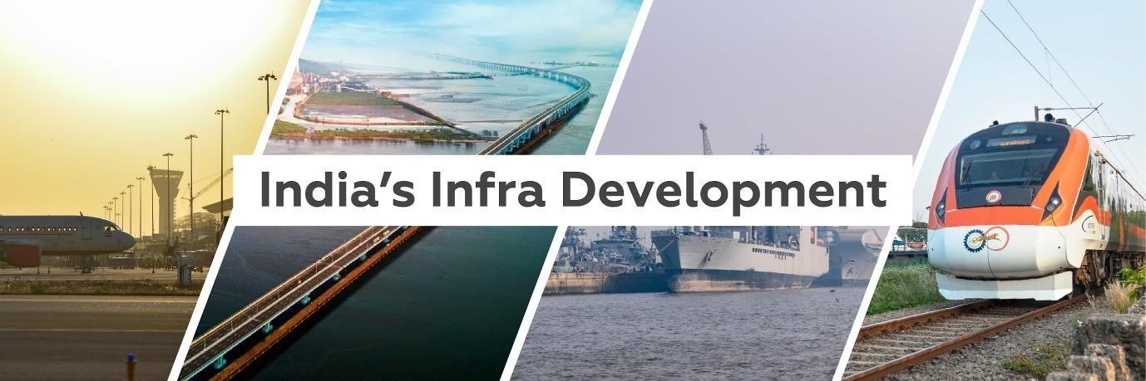

To improve infrastructure and address challenges across states in Central India, governments may implement various policy schemes and future plans based on the analysis of state-wise data on road length. Here are some potential initiatives:
- Bharatmala Pariyojana: This is a flagship infrastructure development project by the Government of India aimed at enhancing road connectivity across the country. Under this scheme, roads and highways in Central India can be upgraded and expanded to improve connectivity within the region and with neighbouring states.

- Pradhan Mantri Gram Sadak Yojana (PMGSY): This scheme focuses on providing allweather road connectivity to unconnected rural areas. Central Indian states can utilize PMGSY funds to upgrade rural roads, improving access to markets, healthcare, and education in remote areas.

- Special Infrastructure Development Fund (SIDF): Central Indian states can establish a dedicated fund to finance infrastructure projects, including road construction, bridges, and flyovers. SIDF can be utilized to address specific infrastructure challenges and promote balanced regional development.

- Public-Private Partnerships (PPPs): Governments can encourage private sector participation in infrastructure development through PPPs. Private investment can accelerate the pace of infrastructure projects and bring in expertise and technology to improve the quality of construction and maintenance.

- Smart City Mission: Central Indian cities can be included under the Smart City Mission to develop modern infrastructure and improve urban services. Smart city initiatives can include the development of smart transportation systems, intelligent traffic management, and the integration of technology to enhance connectivity and mobility.

CONCLUSION
This study discussed the effect of road infrastructure development (i.e. the growth of road length per thousand population) and other socioeconomic factors (i.e. exports, education, physical capital stock and urbanization) on economic growth. The results indicated that road infrastructure development, export, education and physical capital stock per worker contributed substantially to economic growth. This implies that policies to improve road infrastructure development, export, education and physical capital stock should be carried out hand-in-hand in order to sustain higher economic growth. Nevertheless, the inverted U-shape dependency relationship between urbanization and economic growth suggested that over urbanization (when urb > 24.52) would lead to a decrease in economic growth. As such, special attention should be paid when implementing the urban growth policy together with other socioeconomic development policies. Another key finding of this study was that the development in road infrastructure would leads to an increase in export growth that would also contributes to economic growth. Several limitations of this study should be noted. First, the road length per thousand population was used in this study to describe the road infrastructure development without considering the road network capacity and connectivity. It is no doubt that countries with greater road network capacity and connectivity would certainly, has greater impact on economic growth. Second, besides socioeconomic factors describe in this study, empirical research also shows that improvements in other transport facilities such as railways [45-46] and infrastructures such as telecommunications [47-48] contributed substantially to economic growth. Thus, including these factors in further study could definitely provide a more comprehensive overview on the factors affecting a country’s economic growth.

REFERNCE
- Canning D and Bennathan E 2000 The social rate of return on infrastructure investments,
Development Research Group, Public Economics and Private Sector Development and Infrastructure Group, World Bank
- Gunasekera K, Anderson W and Lakshmanan T R 2008 Highway-induced development: evidence from Sri Lanka World Development 36(11) 2371-89
- Fan S and Chan-Kang C 2008 Regional Road development, rural and urban poverty: Evidence from China Transport Policy 15 305-14
- Ding C 2013 Transport development, regional concentration and economic growth Urban Studies 50(2) 312-28
- Zhang X 2013 Has transport infrastructure promoted regional economic growth? – With an analysis of the spatial spillover effects of transport infrastructure Social Sciences in China 34(2) 24-47
- Jiwattanakulpaisarn P, Noland R B, Graham D J and Polak J W 2009a Highway infrastructure and state-level employment: a causal spatial analysis Papers in Regional Science 88(1) 133- 60
- Meyer M D and Miller E J 2001 Urban transportation planning 2nd edition (New York: McGraw
Hill)
- Motamed M J, Florax R J G M and Masters W A 2014 Agriculture, transportation and the timing of urbanization: global analysis at the grid cell level Journal of Economic Growth 19 339-68
- Saunders S C, Mislivets M R, Chen J Q and Cleland D T 2002 Effects of roads on landscape structure within nested ecological units of the Northern Great Lakes Region, USA Biological
Conservation 103(2) 209-25
- Aljoufie M, Brussel M, Zuidgeest M and van Maarseveen M 2013 Urban growth and transport infrastructure interaction in Jeddah between 1980 and 2007 International Journal of Applied Earth Observation and Geoinformation 21 493-505
- Ministry of Road Transport and Highways, Government of India. Date: Nov 15, 2023
- India’s Push for Infrastructure Development by Deewangi Sharma 23-Feb-2024
- Singh, A., Gupta, S. (2017). Role of Road Infrastructure in Economic Development: Evidence from Madhya Pradesh. International Journal of Transport Economics, 44(3), 367-382.
- Kumar, R., Sahu, P. (2018). Enhancing Connectivity through State Highways in Chhattisgarh: Opportunities and Challenges. Journal of Infrastructure Development20(4), 523-537.
- Singh, R., Kerketta, S. (2019). Challenges and Opportunities in Road Infrastructure Development: A Case Study of Jharkhand. Journal of Transportation Engineering, 145, (6), 04019037.
- Mitra, S., Ghosh, A. (2020). Road Infrastructure Development and Regional Disparities in West Bengal. Transport Policy, 90, 102-112.

Abstract
. Stimulating economic growth and development of road infrastructure in economical lagging regions is the goal of many countries. This is because road infrastructure plays a crucial role by providing mobility for the efficient movements of people and goods, as well as providing accessibility to a wide variety of commercial and social activities. However, to achieve a sustainable economic growth, focusing on road infrastructure development alone would not be sufficient. Thus, this study analyse the contribution of road infrastructure development and other socio-economic factors that contributed to economic growth. To shed light on this issue, fixed-effects panel linear regression analysis was conducted using timeseries cross-sectional data for 60 countries over the period of 3 decades from 1980 to 2010. The key finding of this study demonstrated that the growth in road length per thousand population, per capita export, per capita education expenditure and physical capital stock per worker contributed positively to economic growth. It was observed that there is an inverted Ushaped dependency relationship between urbanization and economic growth. That is, the economic growth increases at low urbanization levels but decreases once urbanization exceeds a threshold level. Moreover, it was also observed that the growth in road length per thousand population would facilitate export growth. In summary, this study suggest that policies focused on road infrastructure development should be implemented hand-in hand with other socioeconomic and urban growth policies, in order to realize a sustainable economic growth.

APPENDIX
Table 1:
Table 1: State-Wise Length of National Highways (2016-2019)
(As at end-March)
(kms)
State/Union Territory | 2016 | 2017 | 2018 | 2019
Chhattisgarh | 3078 | 3523 | 3523 | 3606
Jharkhand | 2654 | 2661 | 2661 | 3367
Madhya Pradesh | 5194 | 8053 | 8053 | 8772
West Bengal | 2956 | 3004 | 3004 | 3665

Table 2:
Table 2: State-Wise Length of State Highways (2016-2019)
(As at end-March)
(kms)
 | 2016 | 2017 | 2018 | 2019
Chhattisgarh | 4462 | 4438 | 4176 | 4176
Jharkhand | 1296 | 1339 | 1232 | 1232
Madhya Pradesh | 10934 | 11389 | 11389 | 11389
West Bengal | 3612 | 3262 | 3262 | 3612

Table 3:
Table 3: State-Wise Length of National Highways (2016-2019 )
(As at end-March)
 |  |  |  |  | (kms)
State/Union Territory | 2016 | 2017 | 2018 |  | 2019
Chhattisgarh | 95809 | 27845 | 102578 |  | 105074
Jharkhand | 66786 | 69871 | 79062 |  | 81245
Madhya Pradesh | 289940 | 342654 | 363972 |  | 365045
West Bengal | 316730 | 322067 | 329126 |  | 283865

